Batch: A2 Roll No.: 16010121045
Experiment / assignment / tutorial No.
Grade: AA / AB / BB / BC / CC / CD /DD

Signature of the Staff In-charge with date

TITLE: Basic Data structure in python

AIM: Use suitable methods to get output for given input.
______________________________________________________________________
Expected OUTCOME of Experiment: Use of basic data structure in Python.
_____________________________________________________________________
Resource Needed: Python IDE
_____________________________________________________________________
Theory:

Python Collections (Arrays)
There are four collection data types in the Python programming language:
- List is a collection which is ordered and changeable. Allows duplicate members.
- Tuple is a collection which is ordered and unchangeable. Allows duplicate members.
- Set is a collection which is unordered and unindexed. No duplicate members.
- Dictionary is a collection which is unordered and changeable. No duplicate members.
When choosing a collection type, it is useful to understand the properties of that type. Choosing the right type for a particular data set could mean retention of meaning, and, it could mean an increase in efficiency or security.

List: Lists are used to store multiple items in a single variable. Lists are created using square brackets. e.g. mylist = ["apple", "banana", "cherry"]

List Methods
Python has a set of built-in methods that you can use on lists. L:list, e:element, i:index
Method | Description
L.append(e) | Adds an element at the end of the list
L.clear() | Removes all the elements from the list
L.copy() | Returns a copy of the list
L.count(e) | Returns the number of elements with the specified value
L.extend(L2) | Add the elements of a list (or any iterable), to the end of the current list
L.index(e) | Returns the index of the first element with the specified value
L.insert(i,e) | Adds an element at the specified position
L.pop(i) | Removes the element at the specified position
L.remove(e) | Removes the item with the specified value
L.reverse() | Reverses the order of the list
L.sort() | Sorts the list

Tuple
Tuples are used to store multiple items in a single variable. A tuple is a collection which is ordered and unchangeable. Tuples are written with round brackets.
e.g. mytuple = ("apple", "banana", "cherry")

Tuple Methods
Python has two built-in methods that you can use on tuples. T:tuple, e:element
Method | Description
T.count(e) | Returns the number of times a specified value occurs in a tuple
T.index(e) | Searches the tuple for a specified value and returns the position of where it was found

Set
Sets are used to store multiple items in a single variable. A set is a collection which is both unordered and unindexed. Sets are written with curly brackets.
e.g. myset = {"apple", "banana", "cherry"}

Set Methods
Python has a set of built-in methods that you can use on sets.
Method | Description
S.add(e) | Adds an element to the set
S.clear() | Removes all the elements from the set
S.copy() | Returns a copy of the set
S1.difference(S2) | Returns a set containing the difference between two or more sets
S1.difference_update(S2) | Removes the items in this set that are also included in another, specified set
S1.discard(e) | Remove the specified item
S1.intersection(S2) | Returns a set, that is the intersection of two other sets
S1.intersection_update(S2) | Removes the items in this set that are not present in other, specified set(s)
S1.isdisjoint(S2) | Returns whether two sets have a intersection or not
S1.issubset(S2) | Returns whether another set contains this set or not
S1.issuperset(S2) | Returns whether this set contains another set or not
S.pop() | Removes an element from the set
S.remove(e) | Removes the specified element
S1.symmetric_difference(S2) | Returns a set with the symmetric differences of two sets
S1.symmetric_difference_update(S2) | inserts the symmetric differences from this set and another
S1.union(S2) | Return a set containing the union of sets
S1.update(L1) | Update the set with the union of this set and others

Dictionary
Dictionaries are used to store data values in key:value pairs. A dictionary is a collection which is ordered (3.7 version onward), changeable and does not allow duplicates.
Dictionaries are written with curly brackets, and have keys and values.
e.g. thisdict = {"brand": "Ford", "model": "Mustang", "year": 1964}

Dictionary Methods
Python has a set of built-in methods that you can use on dictionaries.
Method | Description
D.clear() | Removes all the elements from the dictionary
D.copy() | Returns a copy of the dictionary
D.get(k) | Returns the value of the specified key
D.items() | Returns a list containing a tuple for each key value pair
D.keys() | Returns a list containing the dictionary's keys
D.pop(k) | Removes the element with the specified key
D.popitem() | Removes the last inserted key-value pair
D.setdefault(k,v) | Returns the value of the specified key. If the key does not exist: insert the key, with the specified value
D.update({k:v}) | Updates the dictionary with the specified key-value pairs
D.values() | Returns a list of all the values in the dictionary

Problem Definition:
1. In below table input variable, python code and output column is given. You have to complete blank cell in every row.
List
Input | Python Code | Output
thislist=["apple","banana","cherry","orange","kiwi","melon","mango"] | print(len(thislist))  print(type(thislist))  print(thislist[1])  print(thislist[-1])  print(thislist[2:5])  print(thislist[:4])  print(thislist[2:]) | 7  <class 'list'>  banana  mango  ['cherry', 'orange', 'kiwi']  ['apple', 'banana', 'cherry', 'orange']  ['cherry', 'orange', 'kiwi', 'melon', 'mango']
thislist = ["orange", "mango", "kiwi", "pineapple", "apple"] | if "apple" in thislist:  print("Yes, 'apple' is in the fruits list")  for x in thislist:  print(x)  for i in range(len(thislist)):  print(thislist[i])  thislist.sort()  print(thislist) | Yes, 'apple' is in the fruits list  orange  mango  kiwi  pineapple  apple  orange  mango  kiwi  pineapple  apple  ['apple', 'kiwi', 'mango', 'orange', 'pineapple']
thislist=["apple","banana","cherry"] | thislist[1]='blackcurrant'  print(thislist) | ['apple','blackcurrant','cherry']
thislist=["apple", "banana", "cherry"] | thislist.insert(2,'watermelon')  print(thislist) | ['apple','banana','watermelon', 'cherry']
thislist=["apple","banana","cherry"] | thislist.append("orange")  print(thislist) | ['apple', 'banana', 'cherry', 'orange'
thislist=["apple", "banana", "cherry"]  tropical=["mango", "pineapple"] | thislist.extend(tropical)  print(thislist) | ['apple', 'banana', 'cherry', 'mango', 'pineapple']
thislist = ["apple", "banana", "cherry"] | thislist.pop(1)  print(thislist) | ['apple', 'cherry']
thislist = ["apple", "banana", "cherry"] | del thislist  print(thislist) | NameError: name 'thislist' is not defined
thislist = ["apple", "banana", "cherry"] | thislist.clear()  print(thislist) | []
thislist = ["apple", "banana", "cherry"] | x=thislist  y= thislist.copy()  thislist.clear()  print(x)  print(y) | []  ['apple', 'banana', 'cherry']
list1 = [5, 6, 7]  list2 = [1, 2, 3] | list3 = list1 + list2  print(list3) | [5, 6, 7, 1, 2, 3]

Tuple
Input | Python Code | Output
x = ("apple",)  y = ("apple") | print(type(x))  print(type(y)) | print(type(x))  print(type(y))
thistuple=("apple","banana","cherry") | print(thistuple[-1]) | cherry
x = ("apple", "banana", "cherry") | x[1] = "kiwi"  print(x) | TypeError: 'tuple' object does not support item assignment
x = ("apple", "banana", "cherry") | y = list(x)  y[1] = "kiwi"  x = tuple(y)  print(x) | ('apple', 'kiwi', 'cherry')
fruits = ("apple", "banana", "cherry", "strawberry", "raspberry") | (green, yellow, *red) = fruits  print(green)  print(yellow)  print(red)  print(type(red)) | apple  banana  ['cherry', 'strawberry', 'raspberry']  <class 'list'>
fruits = ("apple", "banana", "cherry") | mytuple = fruits * 2  print(mytuple.count("apple"))  print(mytuple.index("banana")) | 2  1

Set
Input | Python Code | Output
myset = {"abc", 34, True, 40.5} | print(myset)  print(len(myset))  print(type(myset))  print(34 in myset)  myset.add("orange")  print(myset) | {40.5, True, 34, 'abc'}  4  <class 'set'>  True  {True, 34, 'abc', 40.5, 'orange'}
thisset = {"apple", "mango", "cherry"}  tropical={"papaya", "mango"} | thisset=thisset+tropical  print(thisset) | TypeError: unsupported operand type(s) for +: 'set' and 'set'
 | thisset.update(tropical)  print(thisset) | {'mango', 'papaya', 'cherry', 'apple'}
 | thisset.intersection_update (tropical)  print(thisset) | {'mango'}
 | thisset.symmetric_difference_update(tropical)  print(thisset) | {'papaya', 'cherry', 'apple'}

Dictionaries
Input | Python Code | Output
thisdict={"brand":"Ford","model": "Mustang","year": 1964, "year": 2020} | print(thisdict)  print(type(thisdict))  print(len(thisdict))  print(thisdict["brand"])  print(thisdict["year"])  x = thisdict.get("model")  print(x)  y = thisdict.keys()  print(y)  z = thisdict.values()  print(z)  thisdict["color"] = "white"  print(thisdict)  if "model" in thisdict:  print("Yes”) | {'brand': 'Ford', 'model': 'Mustang', 'year': 2020}  <class 'dict'>  3  Ford  2020  Mustang  dict_keys(['brand', 'model', 'year'])  dict_values(['Ford', 'Mustang', 2020])  {'brand': 'Ford', 'model': 'Mustang', 'year': 2020, 'color': 'white'}  Yes
 | thisdict["year"] = 2018  print(thisdict) | {'brand': 'Ford', 'model': 'Mustang', 'year': 2018}
 | thisdict.pop("model")  print(thisdict) | {'brand': 'Ford', 'year': 2020}
 | for x in thisdict:  print(x)  print(thisdict[x]) | brand  Ford  model  Mustang  year  2020
 | for x, y in thisdict.items():  print(x, y) | brand Ford  model Mustang  year 2020

2. Write a python program to take list values as input parameters and returns another list without any duplicates.
3. Write a program that takes a string as input from user and computes the frequency of each letters. Use a variable of dictionary type to maintain the count.

Books/ Journals/ Websites referred:

- Reema Thareja, Python Programming: Using Problem Solving Approach, Oxford University Press, First Edition 2017, India
- Sheetal Taneja and Naveen Kumar, Python Programming: A modular Approach, Pearson India, Second Edition 2018,India

Implementation details:

2.

list1=input("Enter the list with duplicates: ").split() #list 1 input
list2=[] #creating an empty list
for x in list1:
list2.append(x) if x not in list2 else 0 # adding non duplicates to another list
print("The final list without any duplicates is: ",list2)

3.

str=input() #takes in string input
dict={} #declare an empty dictionary
for i in str: #iterate through string
if i in dict:
dict[i]+=1 #increase count
else:
dict[i]=1 #if not present then add one occ
print(dict)

Output(s):

2.

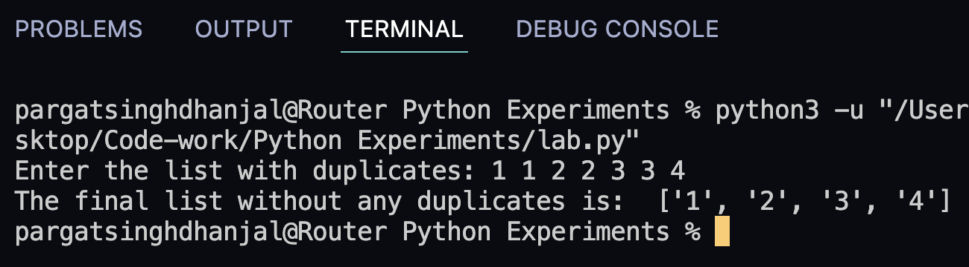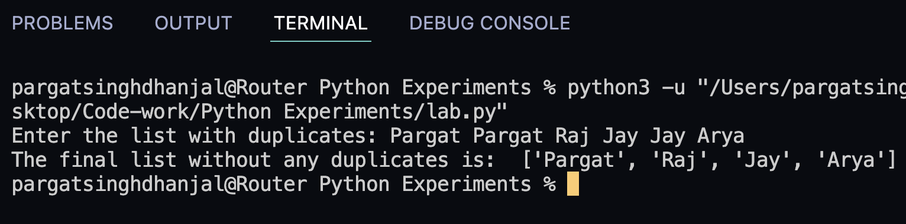

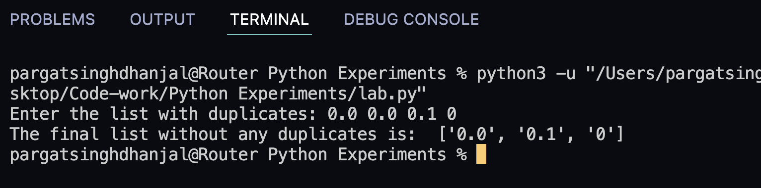

3.

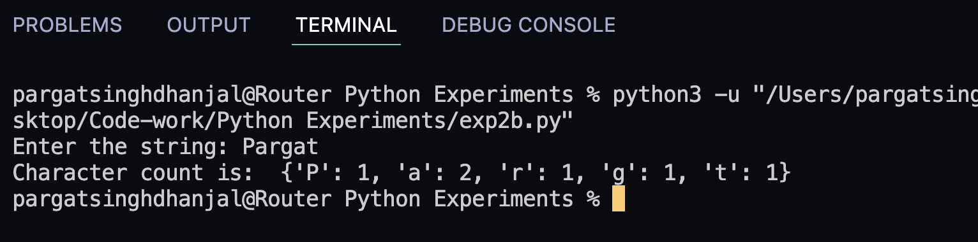

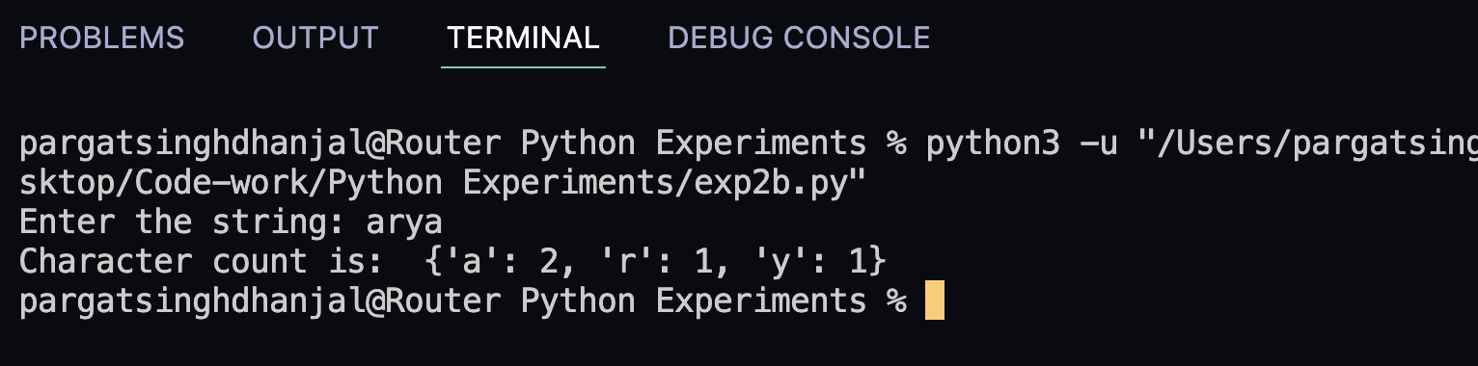

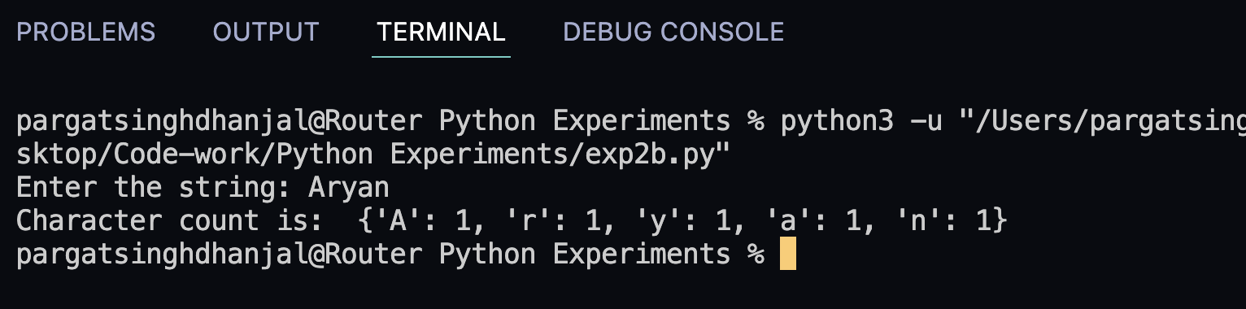

Conclusion:

The necessary output was filled in the table and the problems were solved to
understand the concepts of list, tuple, set and dictionaries and the concepts were
applied in the remaining questions.

Post Lab Descriptive Questions
- List out Mutable and Immutable Data Types in Python.

a. Mutable data types are:- list, dictionary, set and user-defined
classes

b. Immutable data types are:- int, float, decimal, bool, string,
tuple, and range

- What do you mean by indexed and ordered data type in python?

Ordered data types are numerically indexed and ordered by
the index of the element. We can access these elements just by knowing their
positions.
Index value data type shows the position at which the integer value
data type is located. It also displays how many times the integer value is
repeated.

Date: _____________ Signature of faculty in-charge

